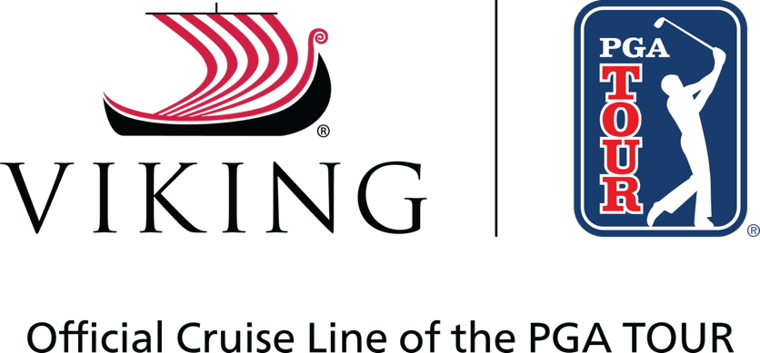

FOR RELEASE: January 8, 2026
CONTACTS: Justin Johns, PGA TOUR, justinjohns@pgatourhq.com
Viking PR team, vikingpr@edelman.com

Viking and PGA TOUR announce new partnership
Viking Becomes Official Cruise Line of the PGA TOUR and PGA TOUR Champions

LOS ANGELES and PONTE VEDRA BEACH, Florida – Viking® (www.viking.com) (NYSE: VIK) and the PGA TOUR today announced a new multi-year marketing partnership that designates Viking as the Official Cruise Line of the PGA TOUR and PGA TOUR Champions.

The agreement, which currently runs through 2030, will center around a brand awareness campaign for Viking through media and digital placements on various PGA TOUR platforms.

“We are very pleased to be the Official Cruise Line of the PGA TOUR and PGA TOUR Champions,” said Richard Marnell, Viking’s Executive Vice President of Marketing. “Both golf and travel are important priorities in the lives of many Viking guests, so partnering with the PGA TOUR is a natural fit and builds on our continued commitment to support cultural programming and events.”

Viking was founded in 1997 with a vision that travel could be more destination-focused and culturally enriching. Today, Viking is a global leader in experiential travel, with a fleet of more than 100 ships, exploring 21 rivers, five oceans and all seven continents.

“We are excited to introduce Viking to our fans across the world as the new Official Cruise Line of the PGA TOUR and PGA TOUR Champions,” said Dan Glod, PGA TOUR Executive Vice President, Corporate Partnerships. “A universally recognized leader in the industry, we’re proud to partner with Viking as they are known for providing memorable and enriching travel experiences that resonate with our players and fans.”

Viking has a longstanding history of supporting cultural programming and events, partnering with prestigious institutions, such as the Los Angeles Philharmonic, the British Museum and the Metropolitan Opera. Viking also recently announced a long-term agreement with the Norwegian Football Federation, making Viking the main sponsor for the National Team Academy (Landslagsskolen) and Norway’s U-level national teams.

###
About PGA TOUR
By showcasing golf’s greatest players, the PGA TOUR engages, inspires and positively impacts our fans, partners and communities worldwide.
The PGA TOUR, headquartered in Ponte Vedra Beach, Florida, co-sanctions events on the PGA TOUR, PGA TOUR Champions, Korn Ferry Tour, PGA TOUR Americas and administers PGA TOUR Q-School presented by Korn Ferry and PGA TOUR University. PGA TOUR members represent the world’s best players, hailing from 28 countries and territories. Showcasing the biggest moments in the sport with history and legacy on the line, the PGA TOUR operates PGA TOUR Studios–a state-of-the-art production studio redefining golf content for fans worldwide—and has long-term domestic distribution partnerships for broadcast coverage on CBS, NBC and Golf Channel, with video streaming service on ESPN+ and additional coverage on multiple Free Ad-Supported Television (FAST) channels. Internationally, the PGA TOUR Studios-produced World Feed is available across 200+ countries and territories in 30 languages via 39 broadcast and digital partners. To date, events across all Tours have generated more than $4 billion in charitable giving. Fans can follow the PGA TOUR at PGATOUR.COM, on the app and in multiple languages across their favorite social media pages.

About Viking
Viking (NYSE: VIK) is a global leader in experiential travel with a fleet of more than 100 ships, exploring 21 rivers, five oceans and all seven continents. Designed for curious travelers with interests in science, history, culture and cuisine, Chairman and CEO Torstein Hagen often says Viking offers experiences For The Thinking Person™. Viking has more than 450 awards to its name, including being rated #1 for Rivers and #1 for Oceans five years in a row by Condé Nast Traveler in the 2025 Readers’ Choice Awards. Viking is also rated a “World’s Best” by Travel + Leisure—no other travel company has simultaneously received such honors by both publications. For additional information, contact Viking at 1-800-2-VIKING (1-800-284-5464) or visit www.viking.com.

